Investigating forces - What do you remember?
- List the three commonly recognised non-contact forces.

- Give three examples of forces other than non-contact forces.

- How can we represent forces in diagrams? Demonstrate this on the image of the plane.

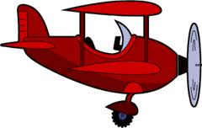

- Complete the sentence. A force is a or a .
- List four things that a force can do to an object.

- What is friction?

- Give an example of a situation in which friction is useful.

